# CS 255 Business Requirements Document Template

Complete this template by replacing the bracketed text with the relevant information.

This template lays out all the different sections that you need to complete for Project One. Each section has guiding questions to prompt your thinking. These questions are meant to guide your initial responses to each area. You are encouraged to go beyond these questions using what you have learned in your readings. You will need to continually reference the interview transcript as you work to make sure that you are addressing your client’s needs. There is no required length for the final document. Instead, the goal is to complete each section based on your client’s needs.

**Tip:** You should respond in a bulleted list for each section. This will make your thoughts easier to reference when you move into the design phase for Project Two. One starter bullet has been provided for you in each section, but you will need to add more.

## System Components and Design

### Purpose

*What is the purpose of this project? Who is the client and what do they want their system to be able to do?*

### The goal of the DriverPass project is to provide a system for a driving school. Customers will be able to schedule and pay for courses using this system. Driving instructors will also be able to take notes to apply to future driving lessons. They also want to be able to keep up with any modifications to the DMW rules. Ultimately, they want DriverPass to be a system that would assist a novice driver in passing the road test.

### System Background

*What does DriverPass want the system to do? What is the problem they want to fix? What are the different components needed for this system?*

### DriverPass intends the system to increase the number of people who pass their driver's license exam. Users and the secretary will require access to a tab in this system to arrange driving lessons. The IT team, on the other hand, has complete control over the system and may make whatever changes they choose. All of this authority should be given to the Big Boss, who should also be able to revoke access at any moment. They should be able to have a tab for online testing, in addition to those security concerns. The system should be able to tell which package each student selected, and if they choose the twelve-hour option, they should have access to online testing.

### Objectives and Goals

*What should this system be able to do when it is completed? What measurable tasks need to be included in the system design to achieve this?*

*The system should be able to manage user data such as first and last names, dates of birth, phone numbers, and addresses after it is finished. It should also be able to deny access to parties that aren't supposed to have access to this information, particularly because it is sensitive. Customers and the secretary should be able to make bookings and enter all of the above information into the system. In the event that a password is lost, there should be a forgotten password option. The boss should also have the ability to cancel access to anyone at any time. As a result, it should be run in the cloud so that it may be utilized on any device. The boss should have access to all information, and given the limited number of slots in DriverPass, he or she should be able to keep track of how many students and teachers the company employs.*

## Requirements

### Nonfunctional Requirements

*In this section, you will detail the different nonfunctional requirements for the DriverPass system. You will need to think about the different things that the system needs to function properly.*

#### Performance Requirements

*What environments (web-based, application, etc.) does this system need to run in? How fast should the system run? How often should the system be updated?*

* The system should work with all major operating systems, including Windows, iOS, Android, and macOS. The app's system must be able to keep up with the web version, thus they should be basically interchangeable in terms of updates, presentation, and general functionality. The system should also be somewhat quick in its operations; consequently, for the best results, employ Wi-Fi or a device's available data. The system should be able to keep up with new DMV laws and standards, allowing for frequent changes. Updates should also be uncomplicated.

#### Platform Constraints

*What platforms (Windows, Unix, etc.) should the system run on? Does the back end require any tools, such as a database, to support this application?*

* Because of Linux's capacity to hold huge applications with little problems, the platform should definitely operate on it. There are a few limitations on Windows, Android, and iOS, but the latter two may be overcome by linking the web browser to the app and pulling information from there. Because DriverPass will operate in the cloud, information will be backed up automatically. Here also necessitates the creation of a database, because, as previously stated, you will need to be able to keep up with new DMV updates, and this is where this information can be updated.

#### Accuracy and Precision

*How will you distinguish between different users?* *Is the input case-sensitive? When should the system inform the admin of a problem?*

* Users should have their own unique username and case-sensitive password to differentiate themselves. Case sensitive passwords provide the highest security and may quickly identify a legitimate user from an unauthorized one. After three failed tries, the administrator should be alerted, and the user should be prompted to answer security questions before receiving a reset password via their registered email. If the reset password link is sent to the registered email address, the user will be notified that someone is attempting to log into their account, and if it is not them, the administrator will be notified by that user.

#### Adaptability

*Can you make changes to the user (add/remove/modify) without changing code? How will the system adapt to platform updates? What type of access does the IT admin need?*

* DriverPass is still a small business and does not wish to hire a systems analyst yet, so modifications should be simple. DriverPass wants the system to be flexible, so you may add, delete, and alter code as the system expands. Updates should be performed when there is less user activity, as well as when operating systems are updated, to accommodate any changes the operating system may bring. IT administrators should also have access to the source code so that they may make modifications and updates in accordance with the DMV standards. In addition, the IT administrator should be able to delete and add new employees to the system, as well as grant them access to the information they require to do their job.

#### Security

*What is required for the user to log in? How can you secure the connection or the data exchange between the client and the server? What should happen to the account if there is a “brute force” hacking attempt? What happens if the user forgets their password?*

* Users will have unique user names and case-sensitive passwords, as previously indicated. When the server is unknown, it should also redirect the user to a webpage to verify the security of the connection or data exchange between the client and the server. All accounts should be logged out if the system is being hacked by brute force, and all users and the IT administrator should be notified. After three failed login attempts, the administrator should be notified, and the user should be asked to answer security questions before obtaining a reset password via their registered email address. If the reset password link is delivered to the registered email address, the user will be alerted that someone is attempting to log into their account; if it is not them, the user will notify the administrator.

### Functional Requirements

*Using the information from the scenario, think about the different functions the system needs to provide. Each of your bullets should start with “The system shall . . .” For example, one functional requirement might be, “The system shall validate user credentials when logging in.”*

* The system shall validate user credentials when logging in.
* The system shall the modification of data on any operating platform.
* The system shall be updated when any new regulations or ordinances are made.
* The system shall be able to display to the customer the specific car and driver to which he or she has been assigned.
* The system shall allow for password resets.
* The system shall be both fast and effective.
* The system shall be simple to use and adaptable.

### User Interface

*What are the needs of the interface? Who are the different users for this interface? What will each user need to be able to do through the interface? How will the user interact with the interface (mobile, browser, etc.)?*

* The user interface must give a positive user experience as well as be visually appealing. Continuing to update along with the operating platforms will help take advantage of current social media trends and events to ensure the user's experience is fresh.
* Users must have the ability to create an account, modify account information, enroll for tests, reserve test slots, and take road lessons, as well as reset their password and deactivate their account.
* Users will engage with the interface via a website, Android or iOS apps.

### Assumptions

*What things were not specifically addressed in your design above? What assumptions are you making in your design about the users or the technology they have?*

* I'm assuming that the IT department will be capable of continuing to make changes to the system without damaging it or forcing our business to intervene.
* I haven't seen any indication that the creators are concerned about their ability to tackle such a project. They just accepted it and have made the required preparations, expecting that they would be able to handle it.
* Everything our company puts in the system's development is based on the premise that they will be able to finance it.
* I'm guessing the system will be totally code-based, with the corporation leveraging third-party hosting for its database and other platforms.

### Limitations

*Any system you build will naturally have limitations. What limitations do you see in your system design? What limitations do you have as far as resources, time, budget, or technology?*

* When compared to online browsers and phone applications, the screen size is a constraint.
* Another constraint is optimization for mobile devices, which have less power and storage capacity.
* We've assigned ourselves a deadline of 5 months to complete this program, but we haven't finalized several key details, such as the budget and their Linux knowledge.
* We also didn't inquire about the average amount of clients Driver Pass anticipates. This is a constraint since we may wind up with a system that does not accommodate their customer traffic.
* The project will need a large expenditure for hosting expenses and database use.
* My system's design does not provide appropriate safeguards against human error.

### Gantt Chart

*Please include a screenshot of the GANTT chart that you created with Lucidchart. Be sure to check that it meets the plan described by the characters in the interview.*

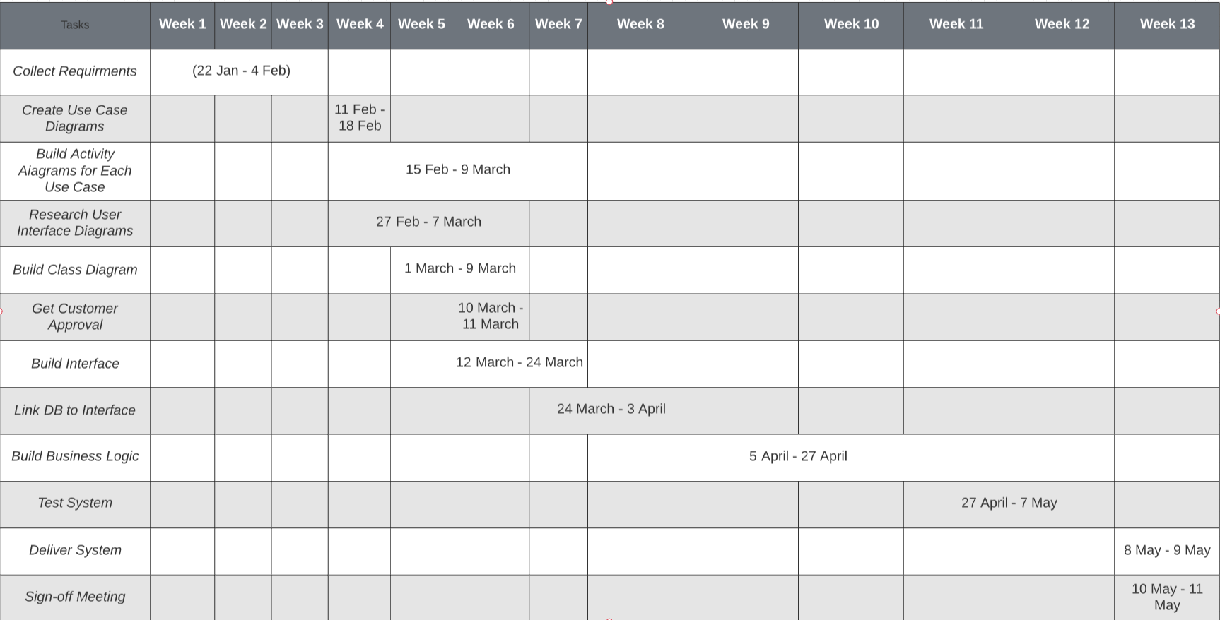

**UML Use Case Diagram**

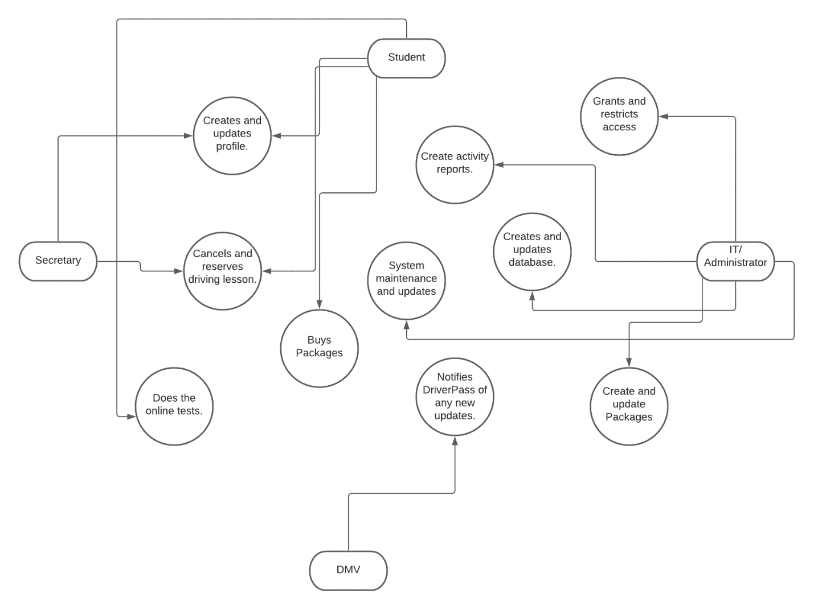

**UML Activity Diagram Use Case 1**

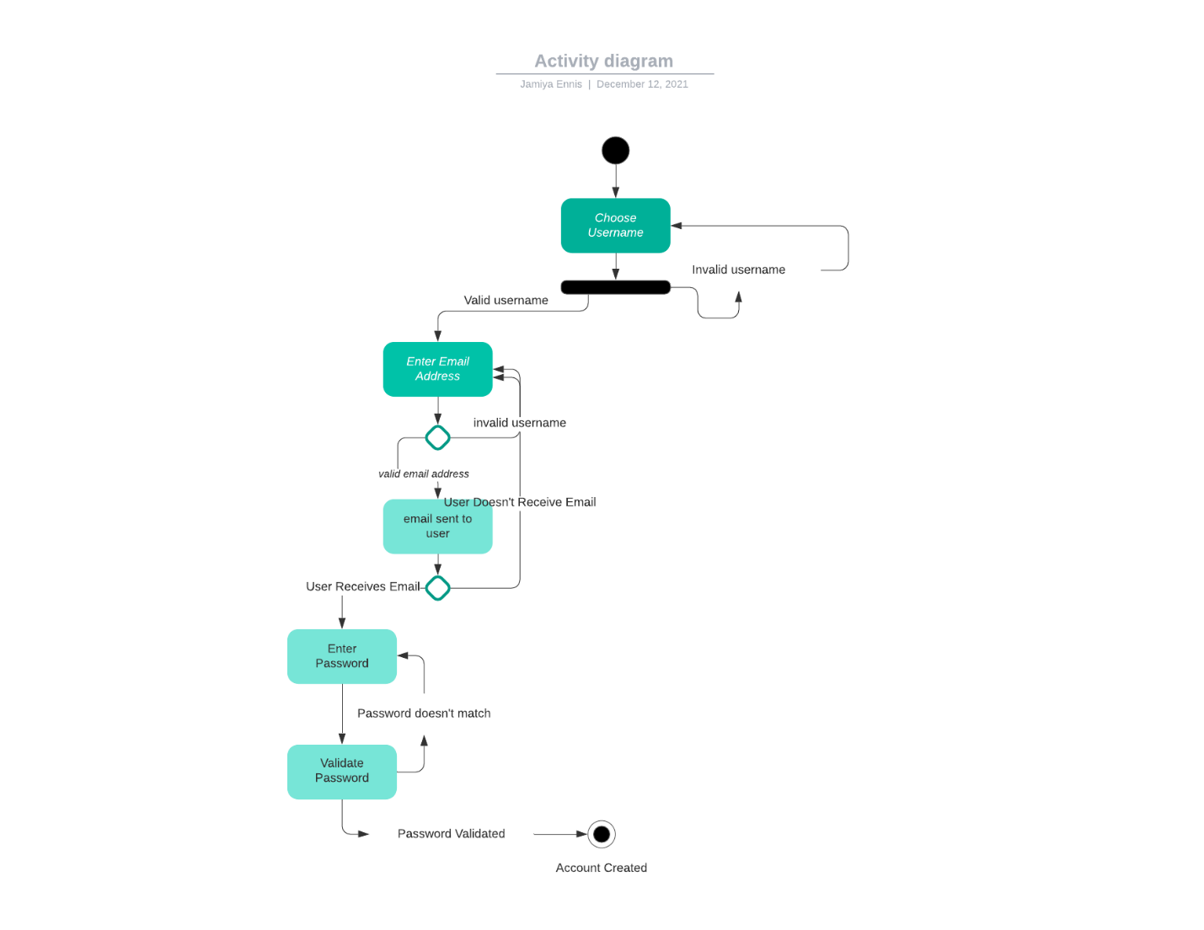

**UML Activity Diagram Use Case 2**

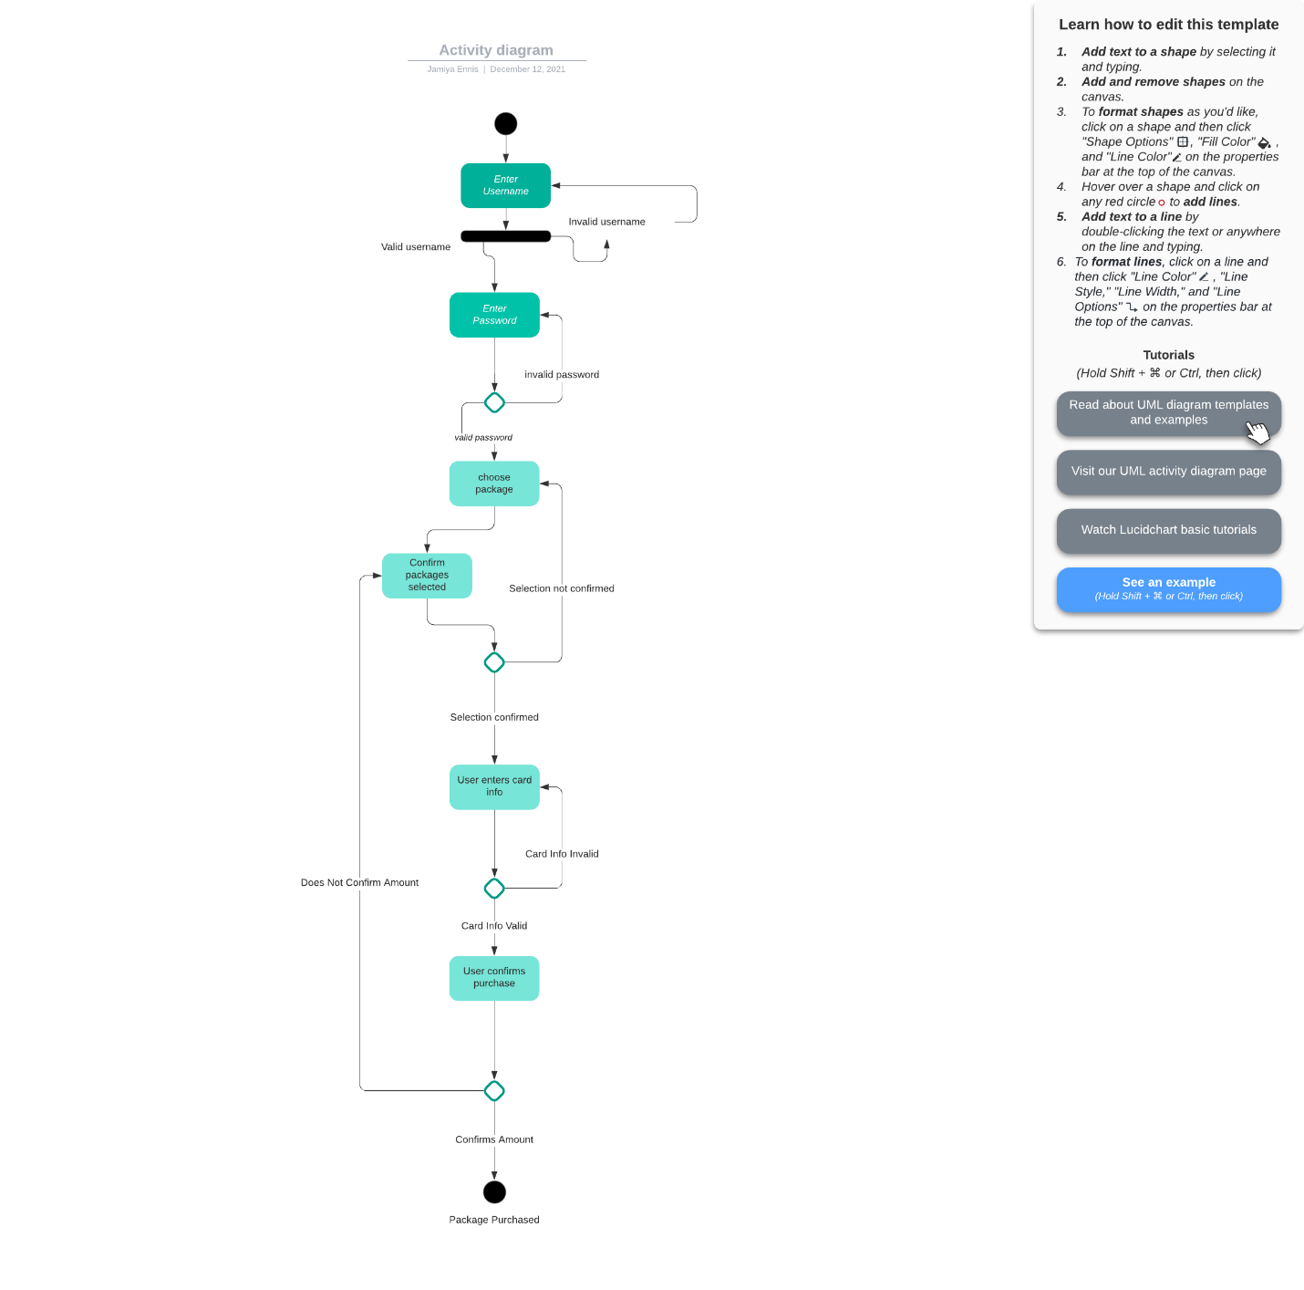

**UML Sequence Diagram**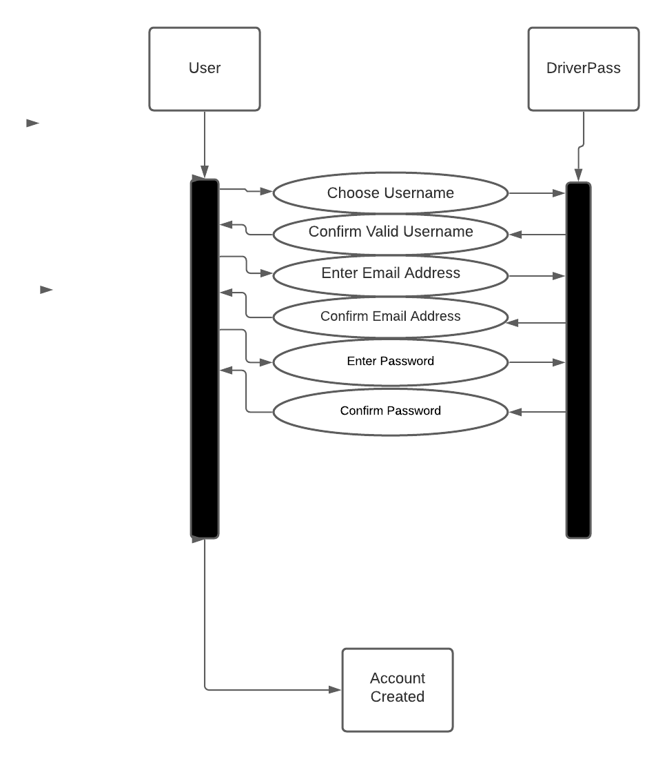

**UML Class Diagram**

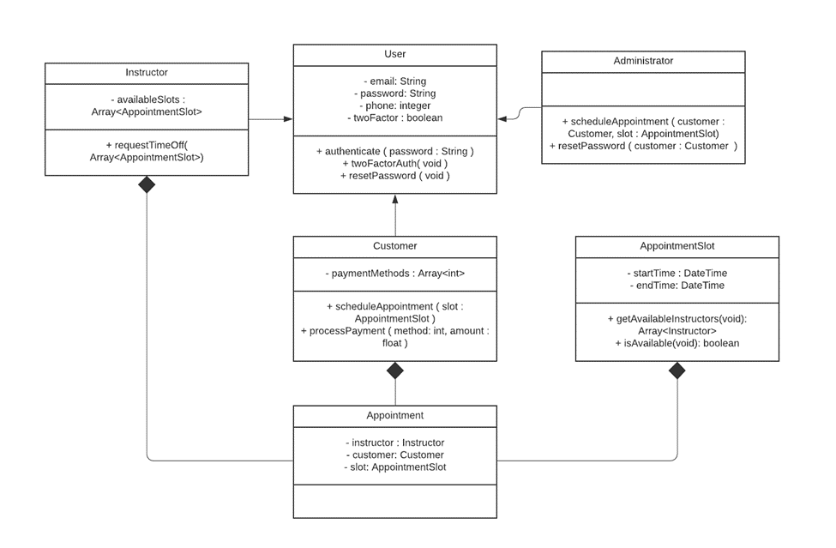

**Technical Requirements**

We'll need to create a web-based system that uses the cloud, as well as a mobile version for the owner to view downloaded data on the move, and a database management system for DriverPass to keep track of all clients. In addition, the system will require adequate security measures, such as ensuring that user passwords are case sensitive and encrypted. Because the app would contain sensitive information such as card numbers, phone numbers, and addresses, the system will also require a password reset system to ensure that outsiders cannot access users' accounts. All major operating systems, including Android, iOS, macOS, Windows, and Lenox, should be able to use the system.